**Electronic supplementary information**

**Interaction OF PolyORGANOSILSESQUIOXANES  
with sulfur**

V. B. Zubchenko, K. A. Pervakov,* I. G. Khalchenko,  
A. V. Shurygin, and N. P. Shapkin

*Far Eastern Federal University,  
pos. Ayaks 10, Russky Island, Vladivostok, Primorskii Krai, 690922 Russia*

**Experimental section**

The work was concerned with vinyltrichlorosilane (bp = 90.0–91.5 °C) and phenyltrichlorosilane (bp = 201–205 °C). Polyvinylsilsesquioxane was obtained from a water–ether medium and dried at 60 °C under vacuum (20 mmHg). Anal. Calcd: C, 30.0; Si, 35.5. Found: C, 28.9; Si, 34.7%. Polyphenylsilsesquioxane was obtained by the published method [S1]. Anal. Calcd: C, 55.8; Si, 21.7. Found: C, 53.8; Si, 20.9%.

The interaction of polyorganylsilsesquioxanes with sulfur was carried out in a heat-resistant glass vessel at a Si:S ratio of 1:1 (PVSQ) and 1:2 (PPSQ). The mixture was pre-processed in a Pulverisette 6 mill at 600 rpm (10 Hz) for 10 min. The resulting mixture was heated at 160–180 °C for 1 h. Anal. Calcd for polymer **2**: C, 21.8; Si, 25.4; S, 28.2. Found: C, 22.0; Si, 24.9; S, 27.5%. Anal. Calcd for polymer **4**: C, 44.7; Si, 17.4; S, 19.9. Found: C, 43.1; Si, 16.6; S, 19.9%.

The IR spectra were recorded on a Perkin Elmer Spectrum 1000 FTIR spectrometer (Argentina). The XRD analysis was performed on a Bruker AXS D8 Advance diffractometer (Germany) using a CuKα source, a Ni filter, at an angle range of 1–60°. The TGA analysis was performed on a Shimadzu DTG-60H analyzer (Japan) with a heating rate of 20 deg/min in air using a platinum crucible. The solid-state 29Si NMR spectra were recorded through polarization transition from protons using a Bruker MSL-400 device at a rate of 4 kHz.

**References**

S1. K. A. Andrianov, *Methods of Organoelement Chemistry*, Nauka, Moscow, **1968**.

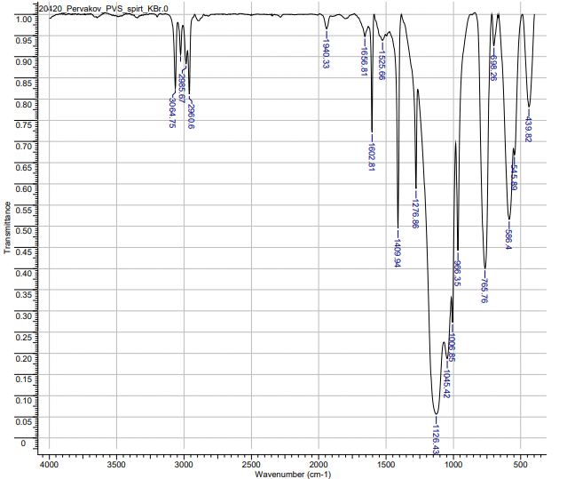

**Figure S1.** IR spectrum of polymer **1**.

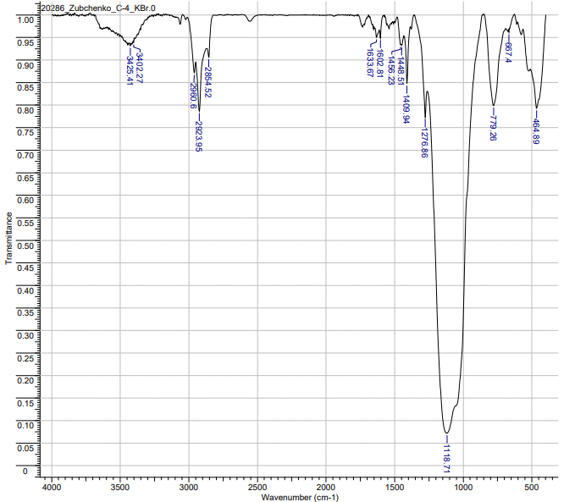

**Figure S2.** IR spectrum of polymer **2**.

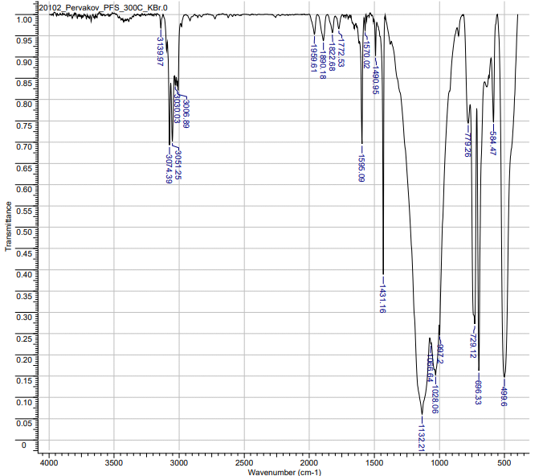

**Figure S3.** IR spectrum of polymer **3**.

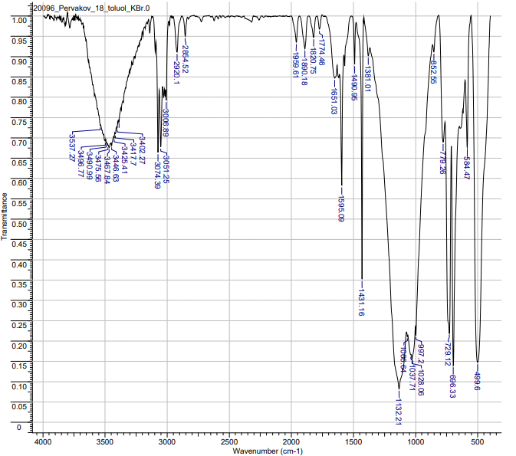

**Figure S4.** IR spectrum of polymer **4**.

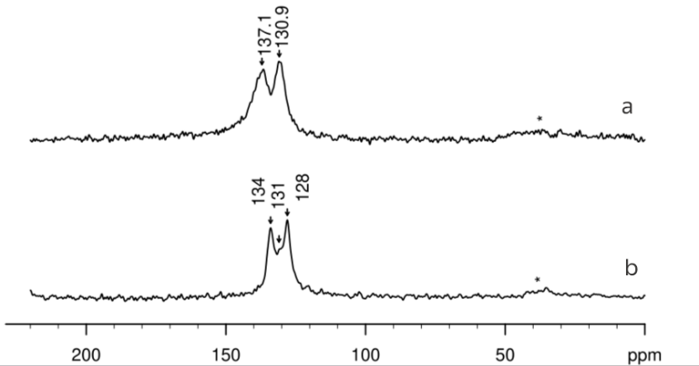h

**Figure S5.** 13C NMR spectrum for polymers **2** (a) and **4** (b).

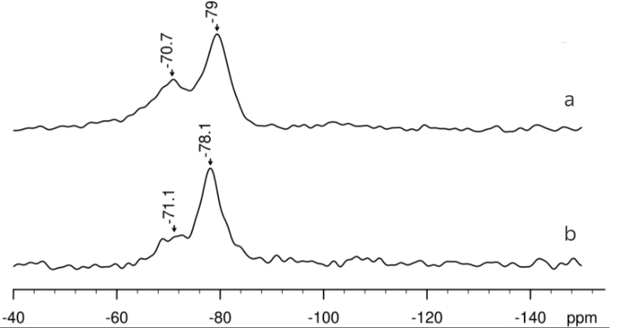

**Figure S6.** 29Si NMR spectrum for polymers **2** (a) and **4** (b).

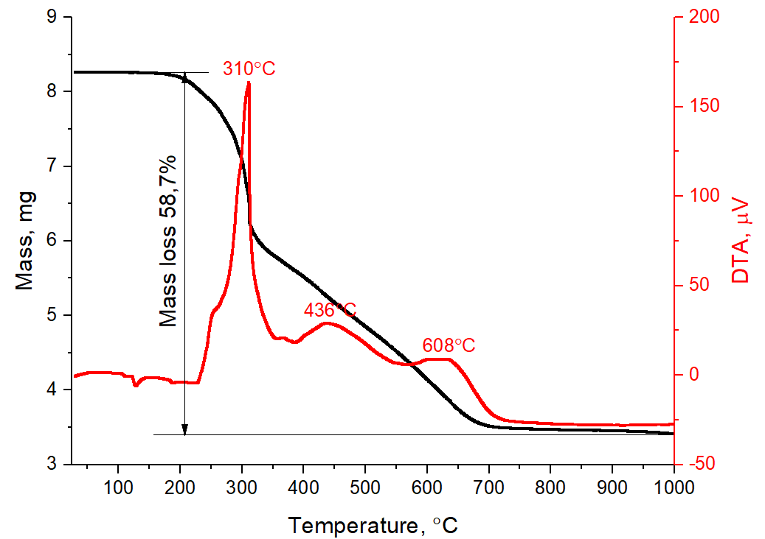

**Figure S7.** Thermogram of the mixture of PVSQ and sulfur.

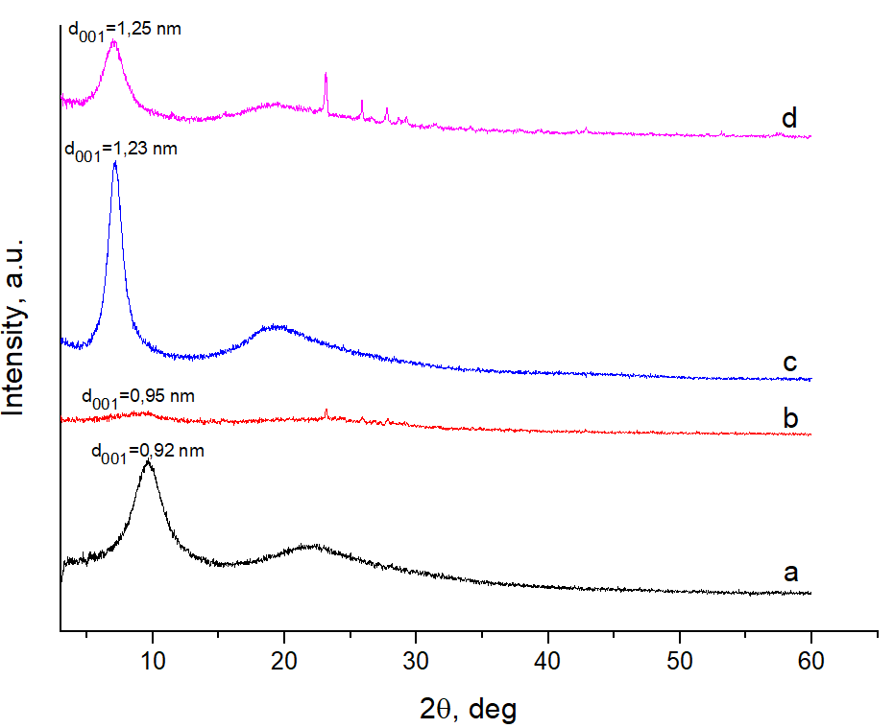

**Figure S8.** XRD patterns of polymers **1**–**4** (a–d).